**THE PATTERNS COMPANY**

4th Floor, Bizness Square Junction Opposite Hitex Road, HITEC City, Madhapur, Hyderabad, Telangana 500084

+91-8500693113

+91-9392744210

[info@thepatternscompany.com](mailto:info@thepatternscompany.com)

https://[www.thepatternscompany.com/](http://www.thepatternscompany.com/)





Website Report for [www.carehospitals.com](http://www.carehospitals.com/)

This report grades your website based on the strength of various SEO factors such as On Page Optimization, O Page Links, Social and more. The overall Grade is on a A+ to F- scale, with most major, industry leading websites in the A range. Improving your grade will generally make your website perform better for users and rank better in search engines. There are recommendations for improving your website at the bottom of the report. Feel free to reach out to us if you’d like us to help with improving your website’s SEO!

Audit Results for [www.carehospitals.com](http://www.carehospitals.com/)



**B-**

# Your page could be better



Recommendations: 16

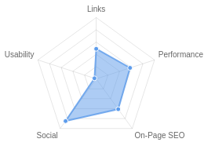



**B**



**C+**



**F**



**B-**



**A+**

On-Page SEO

Links

Usability

Performance

Social

Recommendations

**Implement a XML sitemaps file**

On-Page SEO

Medium Priority

**Optimize for Core Web Vitals**

Usability

Medium Priority

**Reduce length of title tag (to between 10 and 70 characters)**

On-Page SEO

Medium Priority

**Shorten meta description (to between 70 and 160 characters)**

On-Page SEO

Medium Priority

**Add H1 Header Tag**

On-Page SEO

Medium Priority

**Improve site load speed**

Performance

Medium Priority

**Update Link URLs to be more human and Search Engine readable**

Links

Low Priority

**Add Alt attributes to all images**

On-Page SEO

Low Priority

**Optimize your page for Mobile PageSpeed Insights**

Usability

Low Priority

**Optimize your page for Desktop PageSpeed Insights**

Usability

Low Priority

**Setup & Install a Facebook Pixel**

Social

Low Priority

**Remove inline styles**

Performance

Low Priority

**Resolve JavaScript errors**

Performance

Low Priority

**Remove iFrames**

Usability

Low Priority

**Review and Increase Font Sizes across devices**

Usability

Low Priority

**Improve the size of tap targets**

Usability

Low Priority

On-Page SEO Results

**Your On-Page SEO could be better**



**B**

Your page has some level of On-Page SEO optimization but could be improved further. On-Page SEO is important to ensure Search Engines can understand your content appropriately and help it rank for relevant keywords. You should ensure that HTML Tag Content is completed correctly and align text content to target keywords.

## Title Tag

You have a title tag, but ideally it should be shortened to between 10 and 70 characters (including spaces).

Best Hospital in Hyderabad | Best Multispeciality Hospital | CARE Hospitals Length : 75

Title tags are very important for search engines to correctly understand and categorize your

content.

## Meta Description Tag

Your page has a meta description tag however, your meta description should ideally be between 70 and 160 characters (including spaces).

CARE Hospitals is one of the Best Hospital in Hyderabad. With a network of more than 13 multispeciality hospitals across India, we o er world-class care and advanced treatments.

Length : 178

A meta description is important for search engines to understand the content of your page, and is often shown as the description text blurb in search results.

## SERP Snippet Preview

This illustrates how your page may appear in Search Results. Note, this is intended as a guide and Search Engines are more frequently generating this content dynamically.

[https://www.carehospitals.com](http://www.carehospitals.com/)

Best Hospital in Hyderabad

CARE Hospitals is one of the Best Hospital in Hyderabad. With a network of more than 13 multispeciality hospitals across India, we offer world-class ...

## Hreflang Usage

Your page is making use of Hre ang attributes.

## Language

Your page is using the lang attribute. Declared: English

## H1 Header Tag Usage

Your page does not have an H1 Header Tag.

The H1 Header Tag is an important way of signaling to search engines what your content is about, and subsequently the keywords it should rank for.

## H2-H6 Header Tag Usage

Your page is making use multiple levels of Header Tags.

Header Tag Frequency

H3

5

H5

0

H6 0

H4 47

H2 11

## Keyword Consistency

Your page's main keywords are distributed well across the important HTML tags.

Individual Keywords

Keyword Title Meta Description

Tag

Headings Tags Page Frequency

hospitals

✓

✓

✓

40

know





✓

12

best

✓

✓



9

treatment



✓

✓

8

read    9

telangana    9

hyderabad    26

care    45

Phrases

Phrase Title Meta Description

Tag

care hospitals    35

Headings Tags Page Frequency

banjara hills    7

hyderabad

telangana







7

banjara hills hyderabad

hitec city hyderabad    6

   6

hills hyderabad    6

hyderabad care    6

hyderabad care hospitals

   6

## Amount of Content

Your page has a good level of textual content, which will assist in it's ranking potential. Word Count: 1041

## Image Alt Attributes

You have images on your page that are missing Alt attributes.

We found 141 images on your page and 34 of them are missing the attribute.

Alt attributes are an often overlooked and simple way to signal to Search Engines what an image is about, and help it rank in image search results.

## Canonical Tag

Your page is using the Canonical Tag.

https://[www.carehospitals.com/](http://www.carehospitals.com/)

## Noindex Tag Test

Your page is not using the Noindex Tag which prevents indexing.

## Noindex Header Test

Your page is not using the Noindex Header which prevents indexing.

## SSL Enabled

Your website has SSL enabled.

## HTTPS Redirect

Your page successfully redirects to a HTTPS (SSL secure) version.

## Robots.txt

Your website appears to have a robots.txt le.

<http://www.carehospitals.com/robots.txt>

## Blocked by Robots.txt

Your page does not appear to be blocked by robots.txt.

## XML Sitemaps

We have not detected or been able to retrieve a XML sitemaps le successfully.

Sitemaps are recommended to ensure that search engines can intelligently crawl all of your pages.

More Sitemaps were found, but not tested.

## Analytics

Your page is using an analytics tool.



Google Analytics

## Schema.org Structured Data

You are using JSON-LD Schema on your page.

Rankings

## Top Keyword Rankings

This shows your top 10 Keyword Rankings in the speci c location. The list is ordered by the keywords that drive the most tra c to your page.

Keyword Country & Language

Position Total

Searches

Estimated Tra c



dragon fruit:

EN

5

673,000

31,563

dragon dragon fruit

EN

6

673,000

22,747

aceclofenac tablets uses

EN

1

74,000

22,496

dragon-dragon fruit

EN

7

673,000

17,228

fnac test

HI

1

49,500

15,048

hospital EN 7 673,000 17,228

pus cells in urinalysis EN 1 60,500 18,392

dragon food fruit EN 6 673,000 22,747

hospitals EN 5 673,000 31,563

dragon fruit EN 5 673,000 31,563

## Total Traffic From Search

This shows you the Estimated Tra c Volume your page receives from it’s Keyword Rankings



# 4,272,250

Monthly Tra c Volume

## Keyword Positions

This shows you a summary of the positions for your Keyword Rankings. The higher you rank, the more likely you are to capture tra c, with recent research showing that as much as 92% of clicks happen on the rst page.

Position Keywords

Position 2-3

3,984

Position 11-20

34,506

Position 31-100

192,798

Position 21-30 33,054

Position 4-10 23,462

Position 1 1,889

Links

## Backlink Summary

You have a strong level of backlink activity to this page.



**57**



**23**

Domain Strength

Page Strength



**2.4k**

Referring Domains

**80.8k**

Backlinks

|  |  |  |  |  |  |
| --- | --- | --- | --- | --- | --- |
| **33.5k**  Nofollow Backlinks | **47.3k**  Dofollow Backlinks | **25**  Edu Backlinks | **2**  Gov Backlinks | **955**  Subnets | **1.3k**  IPs |

## Top Backlinks

These are the highest value external pages we have found linking to your site.

Domain strength

Referring Page URL

96

https://[www.bing.com/images/search?view=detailV2&ccid=1TUCwlPP&id=F9F552A8968884C0ABA](http://www.bing.com/images/search?view=detailV2&ccid=1TUCwlPP&id=F9F552A8968884C0ABA)

D5B06E6F934A1234D5C95&thid=OIP.1TUCwlPPrjYw1ttwXORXewAAAA&mediaurl=[http://d3n8a8pr](http://d3n8a8pr/) o7vhmx.cloudfront.net/themes/5695627de2954efbfa000001/attachments/original/1515121786/p atient-safety2018.png%3F1515121786&exph=207&expw=353&q=patient+safety+awareness+week &simid=608040661200539314&selectedindex=11&qpvt=patient+safety+awareness+week&mode= overlay&adlt=demote&shtp=GetUrl&shid=54ab28e6-086b-4d31-9359-f7958a065dc4&shtk=VW5pd GVkIGZvciBQYXRpZW50IFNhZmV0eSBDYW1wYWlnbg%3D%3D&shdk=Rm91bmQgdGhpcyBpbWFn ZSBhdCBkM244YThwcm83dmhteC5jbG91ZGZyb250Lm5ldCBvbiBCaW5n&shhk=%2BlxQmdmjygpb 2lfnRmau%2BwxIJOqFEEh/vJI3kZOx02M%3D&form=EX0023&shth=OSH.nK7nErT3Z5J%252BS74uN 8JBKA

97

https://commons.wikimedia.org/wiki/Category:Care_Hospitals

96

<http://groundwork.mit.edu/past-partners/>

96

https://hbr.org/2013/10/why-cant-u-s-health-care-costs-be-cut-in-half?language=es

94

https://blogs.worldbank.org/developmenttalk/health-system-innovation-in-india-part-iii

93 https://[www.newsweek.com/rankings/worlds-best-hospitals-2023/india](http://www.newsweek.com/rankings/worlds-best-hospitals-2023/india)

96 https://bg.hbr.org/2013/10/why-cant-u-s-health-care-costs-be-cut-in-half

97 [http://www.](http://www/) ickr.com/photos/163644217@N06/30515693858/in/pool-1862287@N25

100 https://en.wikipedia.org/wiki/Kendrapara

## Top Pages by Backlinks

These are the pages on your site with the most the backlinks from other sites.

URL Backlinks

<http://www.carehospitals.com/>

2,676

https://[www.carehospitals.com/indore/](http://www.carehospitals.com/indore/)

1,657

<http://www.carehospitals.com/spdoctors-orthopedics>

1,125

[http://www.carehospitals.com/specialty/nephrology/conditions-treatment...](http://www.carehospitals.com/specialty/nephrology/conditions-treatment)

996

<http://www.carehospitals.com/spservices-neurosciences>

975

<http://www.carehospitals.com/spdoctors-neurosciences> 993

[http://www.carehospitals.com/specialty/orthopedics/services-procedures...](http://www.carehospitals.com/specialty/orthopedics/services-procedures) 1,118

[http://www.carehospitals.com/specialty/orthopedics/conditions-treatmen...](http://www.carehospitals.com/specialty/orthopedics/conditions-treatmen) 1,415

https://[www.carehospitals.com/campaign/stroke-risk-assessment/](http://www.carehospitals.com/campaign/stroke-risk-assessment/) 2,464

https://[www.carehospitals.com/](http://www.carehospitals.com/) 4,213

## Top Anchors by Backlinks

These are the top pieces of Anchor Text we found used to link to your site.

Anchor Backlinks

https://[www.carehospitals.com](http://www.carehospitals.com/)

4,350

Go Now

2,334

worst cardiology hospitals - [www.carehospitals.com](http://www.carehospitals.com/)

1,619

carehospitals.com

940

554763. carehospitals.com

844

Dr Bipin Bihari Mohanty - Heart Specialist in Bhubaneswar 866

VM홈페이지 공지사항 - ※─윈스카지노☆ a0987.com ─★우리카지노 1,441

CARE CHL Hospitals 1,659

Stroke Risk Assessment 2,466

[http://www.carehospitals.com](http://www.carehospitals.com/) 26,203

## Top Referring Domain Geographies

These are the Top Geographies we have found linking to your site.

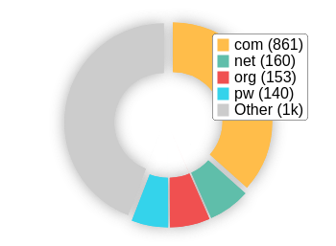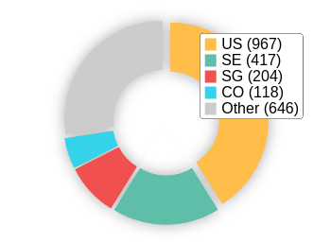Top TLDs Top Countries

## On-Page Link Structure

We found 789 total links. 6% of your links are external links and are sending authority to other sites. 0% of your links are nofollow links, meaning authority is not being passed to those destination pages.

## Friendly Links

Some of your link URLs do not appear friendly to humans or search engines.

We would recommend making URLs as readable as possible by reducing length, le names, code strings and special characters.

Usability

## Your usability needs improvement



**F**

Your page has usability issues across devices. Usability is important to maximize your available audience and minimize user bounce rates (which can indirectly a ect your search engine rankings).

## Device Rendering

This check visually demonstrates how your page renders on di erent devices. It is important that your page is optimized for mobile and tablet experiences as today the majority of web tra c comes from these sources.

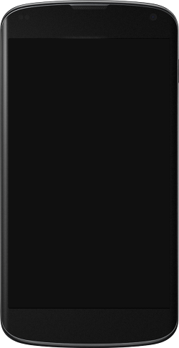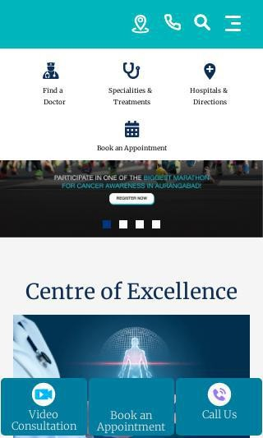

## Google's Core Web Vitals

Your page has failed Google's Core Web Vitals assessment.

Core Web Vitals are UI metrics created by Google that measure page experience and are becoming increasingly important as a ranking factor.

Largest Contentful Paint (LCP)

First Input Delay (FID)

Cumulative Layout Shift (CLS)

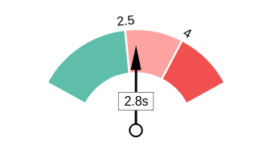 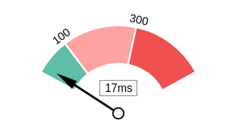 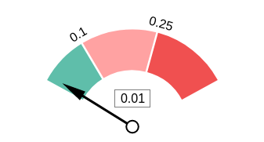

## Use of Mobile Viewports

Your page speci es a viewport matching the device's size, allowing it to render appropriately across devices.

## Google's PageSpeed Insights - Mobile

Google is indicating that your page is scoring poorly on their Mobile PageSpeed Insights evaluation.

Note that this evaluation is being performed from US servers and the results may di er slightly from an evaluation carried out from Google's PageSpeed Web Interface as that reporting localizes to the region in which you are running the report.

Google has indicated that the performance of a webpage is becoming more important from a user and subsequently ranking perspective.



**62**

Lab Data Value

Speed Index

12.8 s

Time to Interactive

6.6 s

Total Blocking Time 0.22 s

Largest Contentful Paint 4.2 s

First Contentful Paint 3.7 s

Opportunities Estimated Savings

Reduce initial server response

time

0.7 s

Avoid multiple page redirects 0.63 s

Cumulative Layout Shift 0.017

## Google's PageSpeed Insights - Desktop

Google is indicating that your page is scoring poorly on their Desktop PageSpeed Insights evaluation.

Google has indicated that the performance of a webpage is becoming more important from a user and subsequently ranking perspective.



**65**

Lab Data Value

Speed Index

4.6 s

Time to Interactive

2.6 s

Total Blocking Time 0 s

Largest Contentful Paint 2.9 s

First Contentful Paint 2.6 s

Opportunities Estimated Savings

Reduce initial server response

time

0.96 s

Avoid multiple page redirects 0.19 s

Cumulative Layout Shift 0.003

## Flash Used?

No Flash content has been identi ed on your page.

## iFrames Used?

Your page appears to be using iFrames.

iFrames are discouraged as they can complicate navigation of content in mobile and have historically been harder to index for search engines.

## Favicon

Your page has speci ed a favicon.

## Email Privacy

No email addresses have been found in plain text on your page.

## Legible Font Sizes

There is some text on your page that is small and may not be legible enough for particular users.

We recommend reviewing all text on your page in di erent devices to ensure that it is of appropriate size.

## Tap Target Sizing

Some of the links or buttons on your page may be too small for a user to easily tap on a touchscreen. Consider making these tap targets larger to provide a better user experience.

Performance Results

## Your performance could be better

Your page's performance has some issues and room for improvement. Performance is important to ensure a good user experience, and reduced bounce rates (which can also indirectly a ect your search engine rankings). We recommend addressing the highlighted factors below.



**B-**

## Page Speed Info

Your page loads slowly.

Page load speed is critical to ensuring good user experience and is becoming a more important ranking factor. Load speed can be impacted by a multitude of factors however and may need technical resources to investigate.

Server Response All Page Content Loaded All Page Scripts Complete

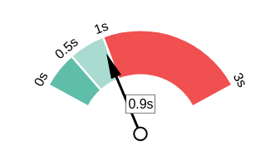 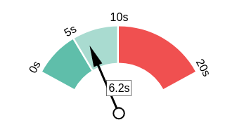 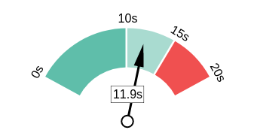

## Download Page Size

Your page's le size is reasonably low which is good for Page Load Speed and user experience.

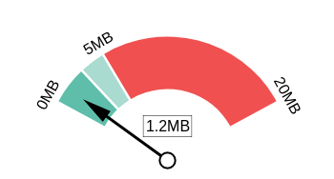Download Page Size Download Page Size Breakdown

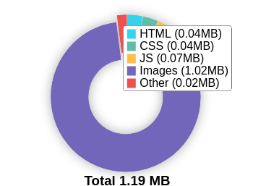

## Website Compression (Gzip, Deflate, Brotli)

Your website appears to be using a reasonable level of compression.

Compression Rates Raw Page Size Breakdown

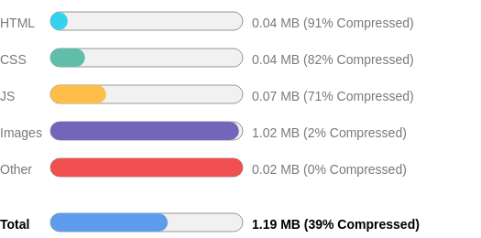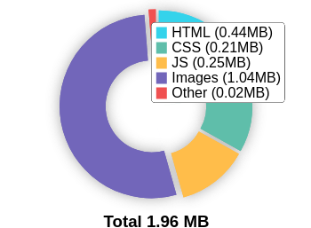

## Number of Resources

This check displays the total number of les that need to be retrieved from web servers to load your page.



# 76

Total Objects

**2**

Number of HTML Pages

**10**

Number of JS Resources

**10**

Number of CSS Resources

**52**

Number of Images

**2**

Other Resources

## Google Accelerated Mobile Pages (AMP)

This page does not appear to have AMP Enabled.

## JavaScript Errors

Your page is reporting JavaScript errors during load.

This could indicate that some required functionality on your page is failing or scripts may have coding problems.

## HTTP2 Usage

Your website is using the recommended HTTP/2+ protocol.

## Optimize Images

All of the images on your page appear to be optimized.

## Minification

All your JavaScript and CSS les appear to be mini ed.

## Deprecated HTML

No deprecated HTML tags have been found within your page.

## Inline Styles

Your page appears to be using inline styles.

Inline styles are an older coding practice and discouraged in favor of using CSS style sheets, due to their ability to degrade page load performance and unnecessarily complicate HTML Code.

Social Results

## Your social is very good!

Congratulations, your social presence is strong and active. Social activity is important for customer communication, brand awareness and as a marketing channel to bring more visitors to your website. We recommend continued use of social campaigns to grow this further.



**A+**

## Facebook Connected

Your page has a link to a Facebook Page.

## Facebook Open Graph Tags

Your page is using Facebook Open Graph Tags.

## Facebook Pixel

We have not detected a Facebook Pixel on your page.

Facebook's Pixel is a useful piece of analytics code that allows you to retarget visitors if you decide to run Facebook Ads in future.

## Twitter Connected

Your page has a link to a Twitter pro le.

## Twitter Cards

Your page is using Twitter Cards.

## Instagram Connected

Your page has a link to an Instagram pro le.

## LinkedIn Connected

Your page has a link to a LinkedIn pro le.

## YouTube Connected

Your page has a link to a YouTube channel.

## YouTube Activity

You have a good number of YouTube channel subscribers

 

# 72,900

Followers

# 15,767,423

View Count

Local SEO

## Local Business Schema

Local Business Schema identi ed on the page.

LocalBusiness

## Google Business Profile Identified

A Google Business Pro le was identi ed that links to this website.



CARE Hospitals, Banjara Hills | Best Hospital in Hyderabad

## Google Business Profile Completeness

The important business details are present on the Google Business Pro le.

Site

https://[www.carehospitals.com/hospital-](http://www.carehospitals.com/hospital-)

detail/care-hospital-banjara-hills

Phone +91 40 6810 6589

Address Rd Number 1, Prem Nagar, Banjara Hills, Hyderabad, Telangana 500034

## Google Reviews

The Google Business Pro le has a good rating and review count.

4.5

★★★★★

5103 reviews

Rating

4

2

1

3

5

Technology Results

## Technology List

These software or coding libraries have been identi ed on your page.

Technology Version



Bootstrap

Cloud are

Google Tag Manager

cdnjs

Apache HTTP Server 2.4.41

HSTS



OWL Carousel

Popper

jQuery

Ubuntu

## Server IP Address

45.249.111.79

**DNS Servers** ns4.ctrls.in ns5.ctrls.in

## Web Server

Apache/2.4.41 (Ubuntu)

## Charset

text/html; charset=UTF-8



[https://www.thepatternscompany.com/](%20%20%20%20%20%20%20%20%20%20%20%20%20%20%20%20%20%20%20%20%20%20%20%20%20%20%20%20%20%20%20%20%20%20%20%20%20%20%20%20%20%20%20%20%20%20https://www.thepatternscompany.com/)

**The Purpose of a Business is to create a Customer Who Creates Customer’s**

**Thank you**